Practical No. 1

Aim: Programs based on printing

Programs:

1. Write a program to print “Hello World”

Source code:

print("Hello World")

Output:



1. Write a program to print your name and address

Source code:

print("Name: Manan Karnik; Address: B/506, Vasundhara C.H.S., Shastri Nagar, Goregaon(West), Mumbai - 400104")

Output:



1. Write a program to print your name and address on multiline

Source code:

print("Name:\nManan Karnik\nAddress:\nB/506,\nVasundhara C.H.S.,\nShastri Nagar,\nGoregaon(West),\nMumbai - 400104")

Output:

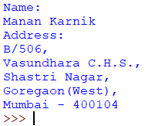

1. Write a python program to print the following pattern

Source code:

print("\t\t\t\t1\n\t\t1\t\t2\t\t1\n\t1\t\t3\t\t3\t\t1\n1\t\t4\t\t6\t\t4\t\t1")

Output:

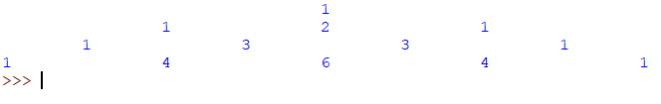

1. Write a python program to print the following pattern

Source code:

print("Year\tAmount\n1\t5550\n2\t6550\n3\t8550\n4\t10050\n5\t15550\n6\t20000\n7\t25000\n8\t35550\n9\t45550\n10\t65550")

Output:

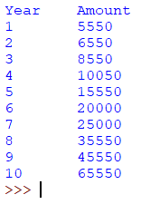

1. Write a python program to print the following pattern

Source code:

print("This\n\tIs\n\t\tMy\n\t\t\tFirst\n\t\t\t\tPython\n\t\t\t\t\tProgram")

Output:

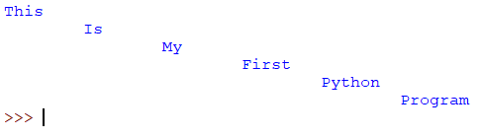

1. Write a python program to print the following pattern

Source code:

print("Name\t:ABC\tAddress\t:Dadar Mumbai 400031\nStd\t:Fy.BSC\tHobbies\t:Playing Cricket and Singing")

Output:



1. Write a python program to print the following pattern

Source code:

print("12345\n\t6789\n\t\t12345\n\t9876\n12345")

Output:

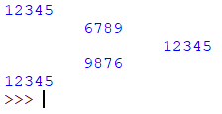

1. Write a python program to print the following pattern

Source code:

print("\* \* \* \* \* \* \* \* \* \* #\n\* \* \* \* \* \* \* \* \* #\n\* \* \* \* \* \* \* \* #\n\* \* \* \* \* \* \* #\n\* \* \* \* \* \* #\n\* \* \* \* \* #\n\* \* \* \* #\n\* \* \* #\n\* \* #\n\* #\n")

Output:

